**Leader-Follower Robots**

**Abstract**

Problem Statement (Basic):

The Slave robot has to trace the path traversed by a Master robot. The master robot is either externally controlled or tracks a line.

Problem Statement (Advanced):

Localize using odometer readings from Master Robot and the Slave robot has to move to that location.

Requirements:

* 1 no - Arduino
* 3 no - Zigbee Modules
* 1 no - IR Array (optional)
* 4 no - DC Motors with encoders
* 2 no - DC Motor Drivers
* 2 no - Chassis

Fabrication:

The robots are assembled with Arduino with Zigbee modules. Both the bots are fitted with dc motors with encoders and connected to the motor drivers. The bots are then paired to each other via Bluetooth for basic task and ZigBee protocol for advanced task.

Algorithm:

Basic:

The Leader robot is controlled to move in a specific path as directed by a mobile via Bluetooth or the bot is made to track a given line using IR Array.

The encoder values are recorded to get the angle and velocity of each of the motors and are sent to the follower robot at regular intervals.

The data transmission is done using a Bluetooth module for this task and the data sent is a series of numbers separated by commas and will be a doublet as (r,l) and each value is a 3 digit value. Once the data is sent the follower sends a conformation if it received everything or else requests to resend the data.

With the data received from the leader robot, the slave robot travels in the same path as traversed by the leader bot with the encoder feedback.

Advanced:

The Leader robot is made to travel in a hardcoded path or externally controlled path.

The encoder values are recorded and the velocity of each wheel and the angle made by the bot are calculated from the known values of R - radius of wheel and L - track of the bot.

The communication of this task is done using ZigBee protocol and the data sent is similar to the previous task.

The data is simultaneously sent to the laptop and processed and the trajectory is displayed on the screen.

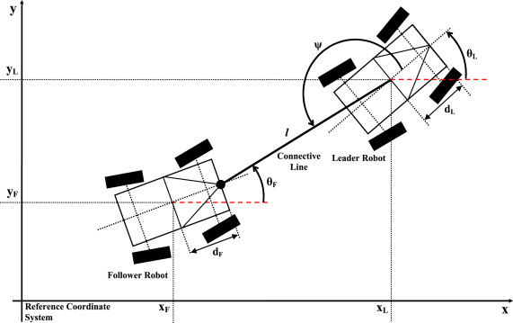

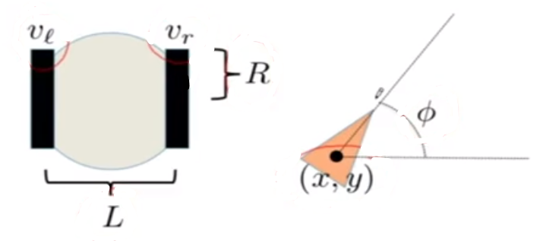

Encoder:

Distance per click, C = $\frac{2πR}{H}$, (H – No. of clicks)

Distance travelled by right wheel, $D_{r}=C_{r}H_{r}$

Similarly for left wheel, $D_{l}=C_{l}H_{l}$

Distance moved by the bot (centre of axle), $∆S=\frac{D_{r}+D_{l}}{2}$

Velocity of bot – v

$\dot{∅}=ω=\frac{R}{L}\left(v_{R}-v_{c}\right)$ And $∅=\frac{D_{r}-D_{l}}{L}$

$\dot{x}=v\cos{∅}=\frac{R}{2}(v_{r}+v_{l})cos{∅}$ And $x=∆S cos{∅}$

$\dot{y}=v\sin{∅}=\frac{R}{2}(v_{r}+v_{l})sin{∅}$ And $y=∆S sin{∅}$

The values are calculated at regular intervals and are updated to ‘x’ and ‘y’ coordinates of the leader bot and sent to the follower for it to know the location of the leader while keeping track of its position.

So, by knowing the distance in x and y directions and its present angle, the follower calculates the angle to be turned and the distance to be covered. The follower moves behind the leader robot using PID to adjust the distance and speed.

Timeline:

Until 13/05 – Vacation

14/05 – Buying the required components

15/05 to 19/05 – Learning how to use the encoder and controlling the dc motor using the encoder feedback. Implementing the concept and control the motor rpm and display values on a serial monitor.

21/05 to 23/05 – Learn about communication using ZigBee protocol and ways to transmit data through the channel.

24/05 to 26/05 – Implement the concept and transmit the data from one bot to another.

28/05 to 31/05 – Fabricate the bot and implementing the concepts to accomplish the basic task. Debugging and completion of basic task.

01/06 to 06/06 – Learning the ways and methods to display the transmitted data on laptop continuously.

07/06 to 09/06 – Implementing it to the leader bot and tracing its path.

11/06 to 16/06 – Learning differential drive and other methods for the slave bot to follow the master, given the coordinates of the master bot.

18/06 to 22/06 – Implementing these concepts into the bots and completion of advanced task.